Part 2:

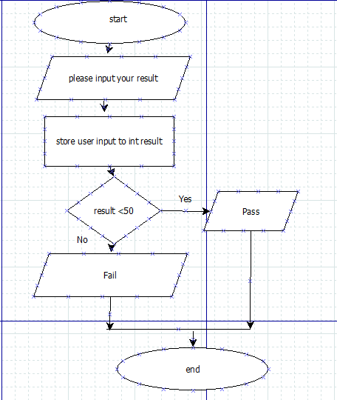

Step 1: start the program

Step 2: ask the user to input their result

Step 3: store the users input to variable int result

Step 4: test the condition If the result is greater than 50 then…

Step5: print “Pass!” and end program

Step 6: test the condition If the result is lessr than 50 then…

Step 7: print “Fail” and end program

Part 3:

Question 14 [TO SCALE WITH LANES IN QUESTION 14 FOLDER]

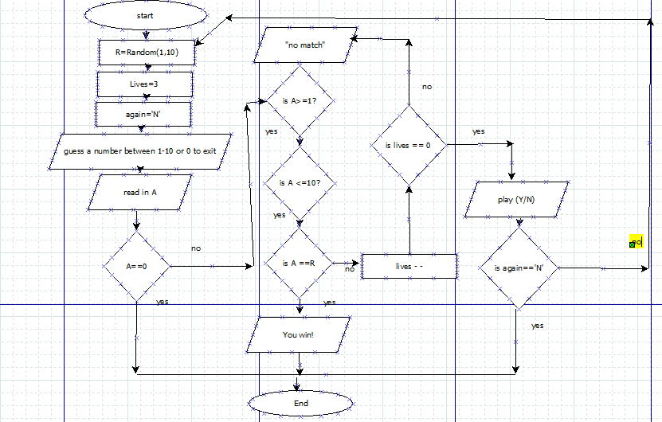

Question 15

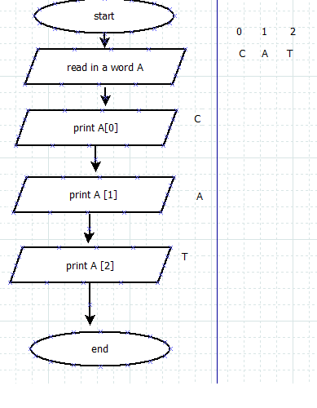

Question 16

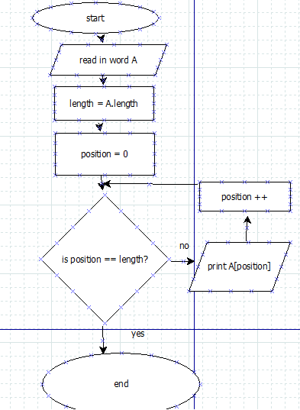

Question 17

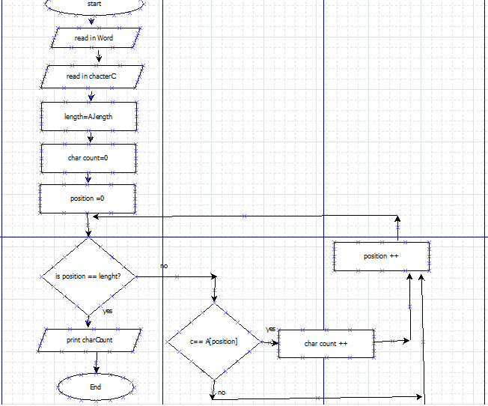

Question 18

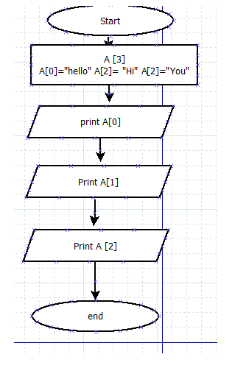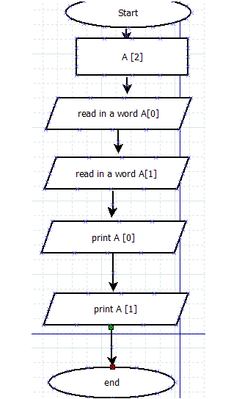

Question 19 >

Question 20

